User Guide 14 Responding to a Referral Request
Purpose of this User Guide
The purpose of this User Guide is to provide guidance to referral authorities and internal referral authorities on how to respond to referral requests in SPEAR.
Details on how referral authorities respond to a notification of a permit application (pursuant to s.52 and s.57B of the Planning and Environment Act 1987) can be found in User Guide 28.
Who should read this?
Primary audience: Referral Authorities, Internal Referral Authorities
For information: Responsible Authorities
Introduction
The approach to responding to referrals in SPEAR varies broadly between referral authorities. Any application that has been referred to a referral authority through SPEAR must be responded to within SPEAR.
Responsible Authorities will be unable to issue a planning permit, certification or Statement of Compliance (SOC) until all statutory responses are in SPEAR. Responding to referrals outside of SPEAR undermines the transparency of the SPEAR workflows and may delay the approval process.
14.1 How do I know what I need to respond to in SPEAR?
Once you login to SPEAR, you will see all the applications currently referred to your organisation. The first column, ‘Action Required’, shows which applications have actions outstanding by your organisation. This is denoted by an orange exclamation. The ‘Outstanding Referrals’ column will display the sections of legislation your organisation has not yet responded to.

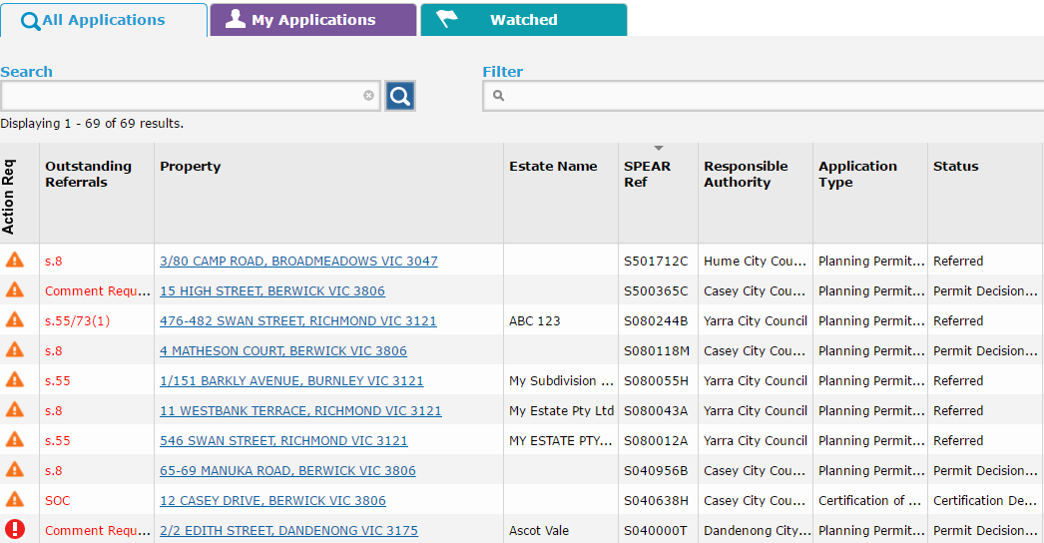

Application List for referral authorities
Sections of legislation not yet responded to can include:
- ‘Section 55’ indicates that your organisation has been referred to under Section 55 of the Planning and Environment Act 1987 and relates to planning permits. The Planning and Environment Act specifies that prior to any permit being granted, the application should be referred, if necessary, under Section 55, and an amended application should be referred under Section 57C. After the permit is granted, applications to amend the permit should be referred under the same Sections but pursuant to Section 73(1).
- Certification and Statement of Compliance (SOC) indicate that your organisation has been referred to under Section 8 of the Subdivision Act 1988 and relates to the certification of the plan of subdivision and the SOC. When a Form 8 and a new plan version are supplied by the applicant, and a re-certification request is accepted by the Responsible Authority, the Responsible Authority action to refer the application should be given under Section 11 of the Subdivision Act.
- ‘Comment’ indicates that your organisation has been referred to so that you may provide a comment on an application. Comments from referral authorities do not prevent an application progressing to the Permit Decision Pending or Certification Decision Pending status. However, SPEAR will not allow the key decision to proceed until all comments have been provided.
- ‘For Info’ indicates that your organisation has been referred to ‘For Information Only’. You are not required to respond but can choose to submit a response by selecting ‘Add Other Document Type’ from the ‘Other Actions’ drop-down list in the Details tab and clicking ‘go’.
All non-statutory referrals are either for ‘Comment’ or ‘For information Only’.
The Details tab will list the mandatory action for your organisation e.g. ‘Add Referral Authority Response (Section 55, Section 8, SOC)’.
To view the referral request added to SPEAR by the Responsible Authority, click the link next to the mandatory action, displayed as (View Referral 14/03/2013). Viewing the referral request is also how you view the prescribed information that council must provide as part of Section 55 or 57C referrals e.g. if your organisation is a determining or recommending referral for this application.
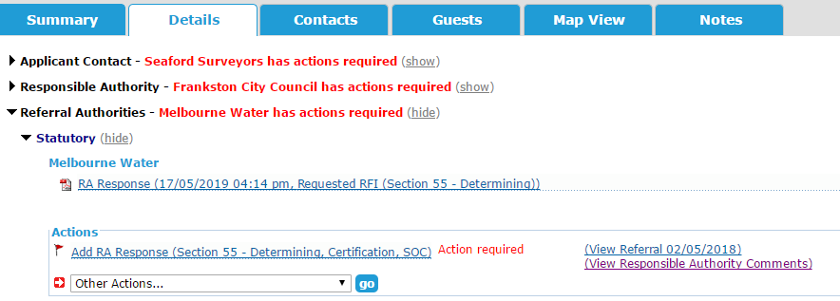

14.2 How do I add my statutory referral response to SPEAR?
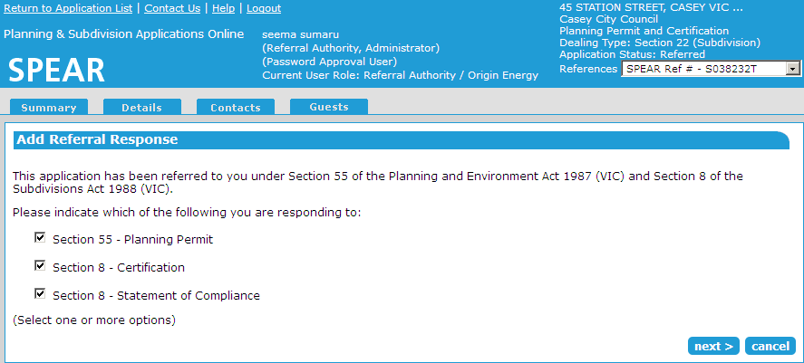
SPEAR requires you select which section of the referral you wish to respond to (you can respond to the referral in parts if you wish). Once you have indicated which sections you are responding to, select ‘next’.

For statutory referrals, users will then be directed to the Response screen where you must define the nature of your response using the radio buttons provided.
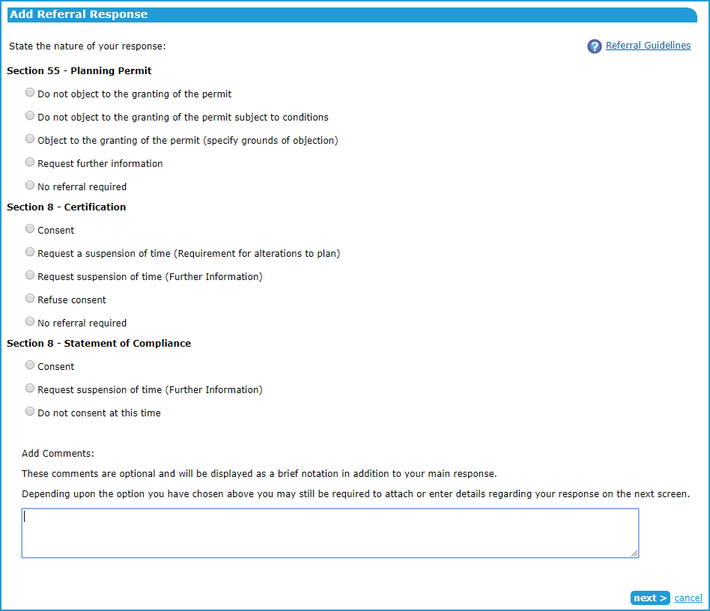
The response options selected on this screen will need to be supported by a formal response (PDF attachment or free text). Make sure that your selections on this screen match the true nature of your response as outlined in your formal response. Discrepancies between your SPEAR selections and your PDF/text may lead to confusion between the Applicant Contact and the Responsible Authority. Make sure you check your response before authenticating.

A comments box is provided at the bottom of this screen. Brief comments typed into this box will appear as a link titled View Referral Authority Comments next to your response and should not include any critical information. These comments can also be viewed by both the Responsible Authority and Applicant Contact.
Once you have completed your selections click ‘next >’.

What is the nature of your response?
The following table describes the meaning of each response type:

Section 55 & 57C (Planning Permit)
Do not object to the granting of the permit | Your response letter has no conditions that the Responsible Authority should include on the planning permit for the Applicant Contact to satisfy.
Do not object to the granting of the permit subject to Conditions | Your response letter contains one or more conditions that the Responsible Authority should include in the planning permit for the Applicant Contact to satisfy.
Object to the granting of the permit (specify rounds of objection) | Your response letter advises the Responsible Authority to refuse the planning permit. You should not select this response unless your organisation thinks the application cannot go ahead at all.
Request Additional Information | The documentation and information provided in the application is not enough to allow you to make a response decision.  Your response should include details about the information you require the Applicant Contact to provide.  This action tells the Responsible Authority and Applicant Contact that further information is required before you will consent to the granting of the permit. The Applicant Contact will have a mandatory action to ‘add a response to Request for Further information’ into SPEAR.
No Referral Required | You are indicating that this application has been referred to your organisation in error and you do not wish to provide any response.

Certification (Section 8 & 11)
Consent | Your response letter consents to the certification of the plan of subdivision. The letter may also describe the steps required to be completed by the applicant before your organisation will consent to Statement of Compliance (SOC).
No Referral Required | You are indicating that this application has been referred to your organisation in error and you do not wish to provide any response.
Refuse Consent | Your response letter advises the Responsible Authority to refuse certification. You should not select this response unless your organisation thinks the application cannot go ahead at all.
Request a suspension of time (Requirement for alterations to the Plan) | The documentation and information provided in the application is not enough to allow you to make a response decision. Your response should include details about the changes you require the Applicant Contact to make to the plan of subdivision.  This action tells the Responsible Authority to stop the statutory clock to allow you more time to respond and tells the applicant contact that changes to the plan are required before you will consent to the certification of the plan. The Applicant Contact will have a mandatory action to add a new version of the plan of subdivision into SPEAR.
Request a suspension of time (Further Information) | The documentation and information provided in the application is not enough to allow you to make a response decision.  Your response should include details about the information you require the Applicant Contact to provide.  This action tells the Responsible Authority to stop the statutory clock to allow you more time to respond and tells the Applicant Contact that further information is required before you will consent to the certification of the plan. The Applicant Contact will have a mandatory action to ‘add a response to Request for Further information’ into SPEAR.

Attaching your referral response:
You may attach your response letter into SPEAR via two methods:
- Attach your letter in PDF format, or
- Type your response (or paste it) into the text box provided and SPEAR will create a PDF format letter for you.
Your response letter should contain all the information you are required to provide for a paper-based response and should be easily identifiable as being from your organisation if it is printed out. Refer to section 14.3 of this User Guide for more information on content.
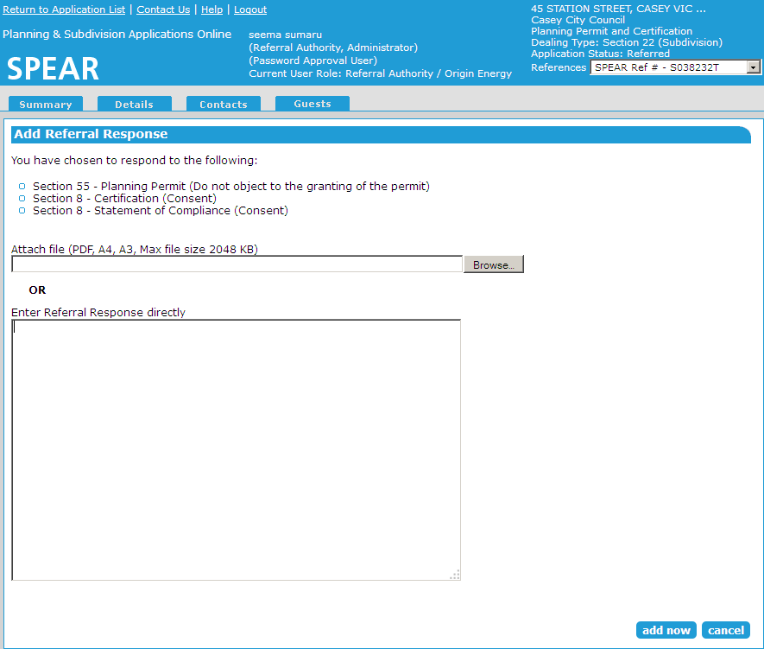

Adding your response letter
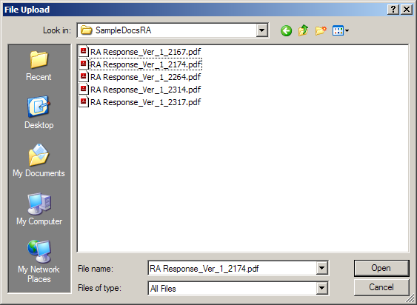
To attach a letter, you have previously created in PDF format, click ‘Browse’. You will be prompted to search through your computer files to find your response document.

Search through your files for your PDF response letter.
Once you have found and highlighted your response document, click ‘Open’.
The file path to your document will now be displayed in the field next to the ‘Browse’ button.
To have SPEAR create a PDF format document for you, type your response details into the text box provided or copy the text of your letter from Word and paste it into the SPEAR text box.
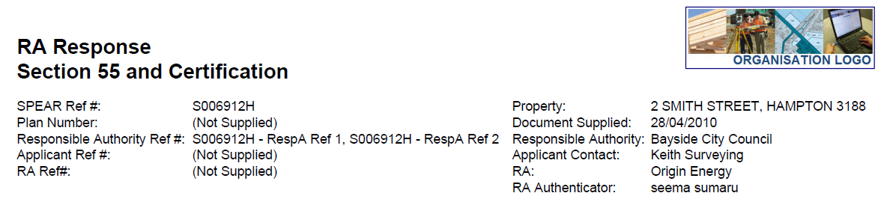
The following header is placed at the top of each page of the PDF format document SPEAR creates for you:
Once you have attached or typed your letter into this screen click ‘add now’.
The response must be authenticated by a SPEAR user with the appropriate level of authorisation in your organisation.
NOTE: If the response is not authenticated, the Responsible Authority and the Applicant Contact will be unable to view the document in SPEAR and will not know that you have responded to the application. Refer to Section 14.5 of this User Guide for instructions on how to authenticate.
14.3 What information should my response include?
This is your statutory response to the referral and should include all the information required to satisfy the legislative requirements of referral responses.
The letter on the next page demonstrates a sample referral response.

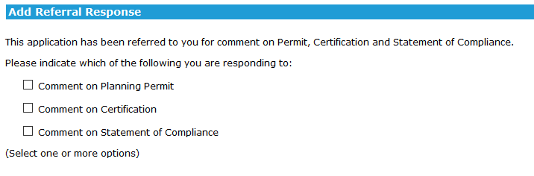
14.4 How do I add my non-statutory referral response to SPEAR?
Non-statutory referrals are ‘For Comment’ only, and do not prevent the Responsible Authority from issuing the planning permit, certification or SOC.
The process for responding to the referral is very similar to the statutory process.
First you will specify which referrals you are responding to by clicking on the appropriate checkboxes
Clearly indicate what consents you are giving and not giving.
Clearly indicate if they are for the planning permit, certification or Statement of Compliance
State any conditions that you require the Responsible Authority to include on the planning permit and the applicant contact to satisfy.
These should be numbered.
- The Date
- Referral Authority Name
- Contact Details of the Responding Officer
At least one identifying reference number or reference details, preferably including the SPEAR Reference Number.
The name and position of the responding officer or staff member.
Our Reference: TP01-996
Your Reference: PLN07/0594

SPEAR Reference: S000874J
Plan of Subdivision No: PS614314G (Version 1)
Location: 1- 9 Best Road, Derbyshire – 2 Lots

5 October 2019

REFERRAL AUTHORITY NAME

Telephone (03) 8636 3049
Facsimile (03) 8636 2588
E-mail Joe.Bloggs@referral.com.au

CONDITIONAL CONSENT TO PERMIT
BUT CERTIFICATION AND COMPLIANCE REQUIRED

Pursuant to Section 56 (1) (b) of the Planning and Environment Act 1987, Referral Authority does not object to the granting of a permit for the above application subject to the following conditions:-

1. Any plan lodged for certification will be referred to the Referral Authority pursuant to Section 8(1)(a) of the Subdivision Act.

2. Reticulated sewerage facilities must be provided to each lot by the owner of the land (or applicant contact, in anticipation of becoming the owner) to the satisfaction of the Referral Authority. This will include the construction of works and the payment of major works contributions by the applicant contact.

3. A reticulated water supply must be provided to each lot by the owner of the land (or applicant contact, in anticipation of becoming the owner) to the satisfaction of the Referral Authority. This will include the construction of works and the payment of major works contributions by the applicant contact.

Referral Authority will not consent to the issue of a Statement of Compliance until such time as the applicant contact provides satisfactory evidence of compliance with the above conditions.

If you have any queries, please contact me on the above telephone number.

Yours faithfully

Joe Bloggs
Referrals Officer

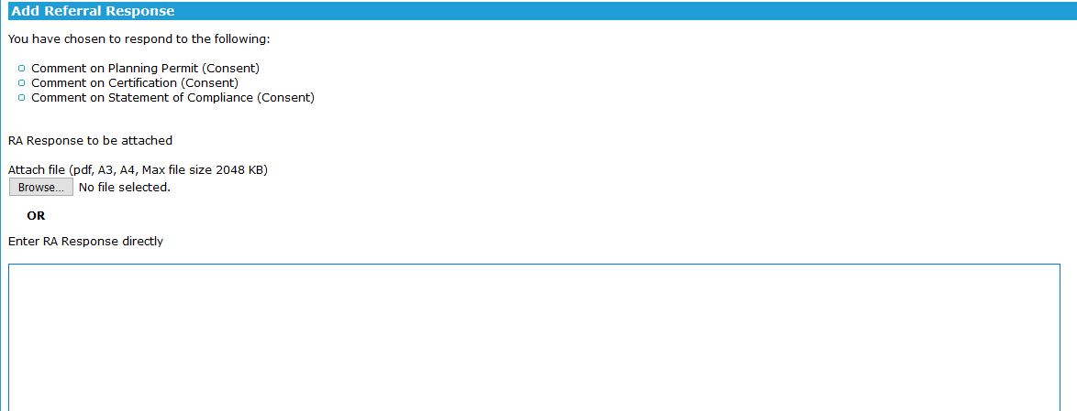
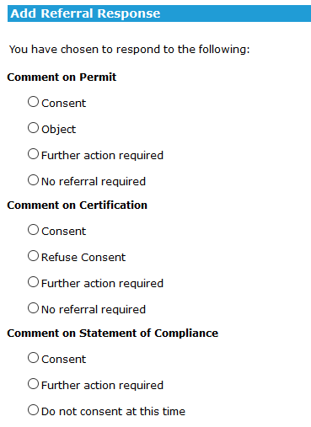
Then select what type of response you are making:

Then either upload a PDF or type your response directly into SPEAR:
14.5 How do I authenticate my response?

Responses must be authenticated by a SPEAR user who has a password level of authorisation (or higher). If the response is not authenticated, the Responsible Authority and the Applicant Contact will be unable to view the document in SPEAR and will not know that you have responded to the application.
Once you have added your response to SPEAR it will appear in your documents list on the Details tab as ‘not authenticated’.
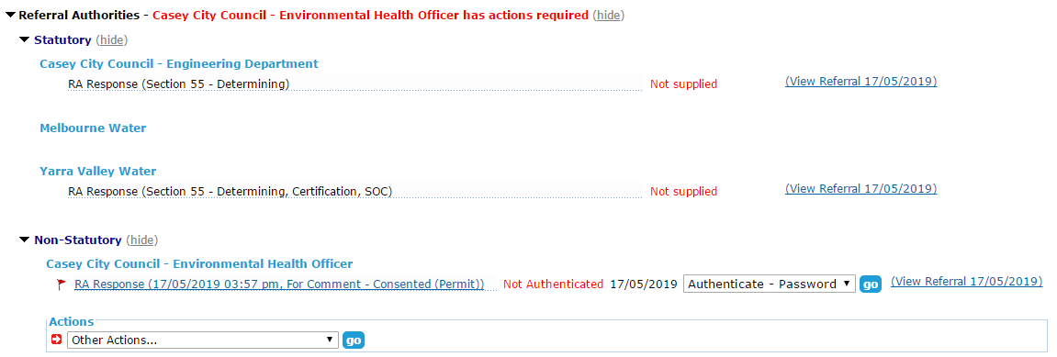
To authenticate the response, click ‘go’.

Authenticating your response
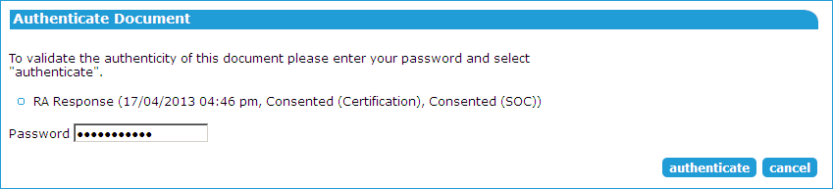
You will be prompted to type in your SPEAR password (the same one you use to login to SPEAR) and click ‘authenticate’.

14.6 Re-referrals
The Responsible Authority may decide to re-refer the application to your organisation, if the Applicant Contact makes significant changes to the application documentation (such as the plan of subdivision). If you have previously added your response to an application in SPEAR, a re-referral will require you to repeat the process and respond again, with consideration of the additional information. SPEAR will determine the relevant sections of the Planning and Environment Act or Subdivision Act under which these re-referrals will be subject to.
Need more information?
Further information on this topic can be found by:
- Visiting the SPEAR website www.spear.land.vic.gov.au/SPEAR
- Contacting the SPEAR Service Desk on 9194 0612 or email spear.info@delwp.vic.gov.au
- Selecting the Help link in the relevant area of the SPEAR system
- Referring to User Guide 3 – Referrals and User Guide 5 - Request for Further Information.

